<https://www.youtube.com/watch?v=AKNvTxWOdKw&list=PL07efmqYWHZ_rVeQ1ws0ER9eL6cxo-d5V&index=5>

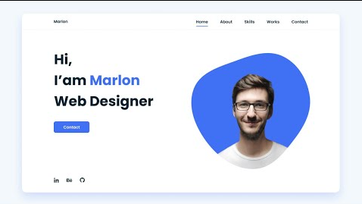

-----------

<https://www.youtube.com/watch?v=27JtRAI3QO8&list=PL07efmqYWHZ_rVeQ1ws0ER9eL6cxo-d5V&index=5>

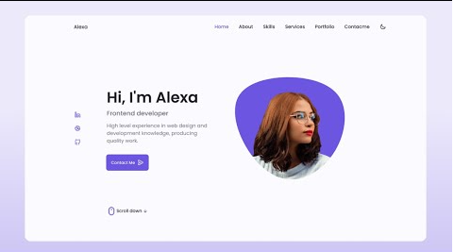

----------

<https://www.youtube.com/watch?v=6cidbUHNZRQ&list=PL07efmqYWHZ_rVeQ1ws0ER9eL6cxo-d5V&index=6>

--------------------

<https://www.youtube.com/watch?v=oy8dSsK57Ps&list=PL07efmqYWHZ_rVeQ1ws0ER9eL6cxo-d5V&index=8>

--------------

<https://www.youtube.com/watch?v=owEHlDn0JYQ&list=PL07efmqYWHZ_rVeQ1ws0ER9eL6cxo-d5V>

--------------------------------------------------------------------------------------------------------------------------------------------------------------------------------------------------------

<https://www.youtube.com/watch?v=QtOzUABE1Z4>

----------

<https://www.youtube.com/watch?v=G2qThIGOcaM&list=RDCMUCKwgH3vASrD2brd1l2m6NHw&index=8>

-------

<https://www.youtube.com/watch?v=CkZ3PVknLY4&t=156s>

-----------------

<https://www.youtube.com/watch?v=hDyeaOfz9xs&t=122s>

-------------------------------

<https://www.youtube.com/watch?v=iX0B6YE9o4Q&t=241s>

